# Solution Report

**Team:** David and Jay

(**note**: while all listed page limits are recommendations, and not absolute restrictions, we do ask that you adhere to them as best you can)

## Part 1: Architecture and use

**Architecture**

Please provide a diagram illustrating the system architecture and briefly explain its components.

*Text/diagram(s) 1 page*

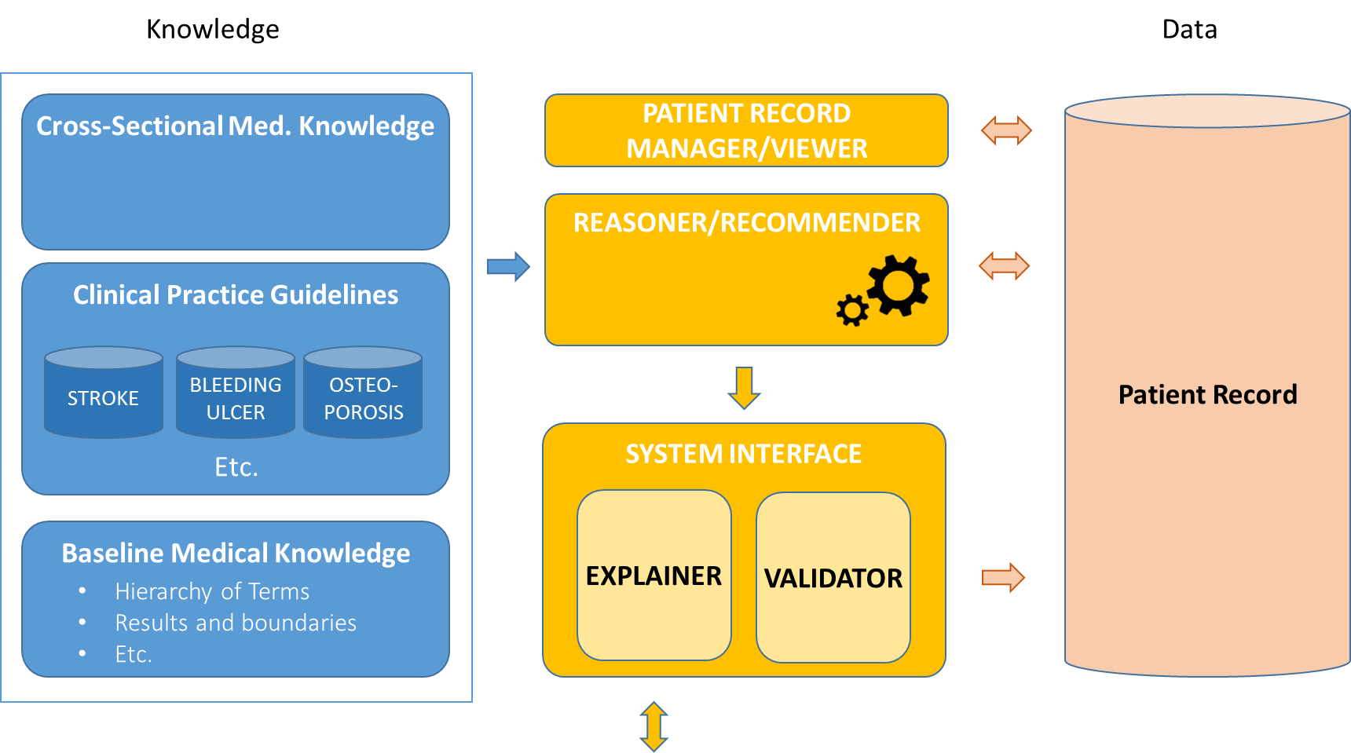

Knowledge is structured at three levels: cross-sectional medical knowledge, clinical practice guidelines knowledge (as isolated CIGs), and baseline medical knowledge. Cross-sectional knowledge do not correspond to a particular pathology but it describes general medical knowledge such as the definition of post-menopausal in the clinical case 1. CPG knowledge contains the procedural and declarative units of knowledge related to the management of particular diseases. These units come from explicit assertions in CPGs and they are formalized as SDA structures (a kind of CIG). Each disease has a separate CIG. Baseline knowledge is formalized as ontologies of health-care concepts (e.g., signs, diseases, clinical procedures and tests, drugs, etc.). Whenever it is possible, with the help of a medical expert, these terms are identified in standard codification systems such as ATC or ICD, though SNOMED-CT is preferred.

Patients are described by a longitudinal list of facts with a complete track of the clinical circumstances of the patient along time. Facts have a time constraint determining the interval when they are observed.

The patient record manager, the reasoner, and the user interface use these knowledge and data components. The patient record manager allows the creation and edition of medical records, if required. The reasoner takes the record of one patient and the knowledge related to that case (i.e., all the cross-sectional and baseline medical knowledge and the CIGs of the related diseases) and deduce the appropriate clinical actions according to the guidelines. These actions may be reflected in the record of the patient or validated by the user of the system before they are added to the record. During the validation, the user can request explanations that clarify the clinical reasons for the recommended actions.

**CIG representation**

Please explain the formalism used to represent CPGs.

*Text/diagram(s) 1 page*

We use *SDA structures* [1] (standing for state-decision-action) to represent longitudinal and sequential clinical procedures in CPGs. They are similar to clinical algorithms. States represent filters on the clinical condition for a patient to be elective for the procedure that follows the corresponding state. Actions are the clinical actions recommended in the CPG (sequential, alternative, parallel, and non-deterministic actions are possible). Decisions guide the clinical procedure in one direction or another according to the evidences and constraints in the CPG. At a graphical level, states are represented by circles, decisions by diamonds, and actions by rectangles that are connected to each other to give rise to more complex clinical procedures. In [2, 3], we also introduced the possibility of representing CPG declarative knowledge, which is punctual and disconnected from a longitudinal strategy of treatment, but which should be considered in the management of patients. This is represented with *SA structures*, similar to if-then rules. The transformation of SDA structures into SA structures was described in [2], thus providing a natural way to integrate SDA and SA knowledge, without modifying the reasoning method.

Conditions in states and decisions, and recommendations in SDA/SA actions, are expressed as conjunctions of facts, each fact being a combination of *clinical concept + value + time constraint*. Clinical concepts are any one of the legal terms contained in the Semantic Medical Terms component (see the system architecture). For instance, weakness (sign), stroke (disease), aspirin (drug), DXA-absorptiometry (procedure/test), etc. Values in facts can be either numeric or categorical and specific, interval, set of alternatives, or semantically predefined (true, false, risk-of, suspected, unspecified, primary, secondary, etc.). Semantically predefined values are hierarchically represented in the Baseline medical knowledge component (see system architecture) so that reasoning with these values occurs naturally. Time constraints in facts allow the definition of temporal knowledge by the use of macro- or micro-temporality expressions [4, 5]. *Macro-temporality* define time intervals so that we can express past, current and future conditions or actions such as “the patient didn’t have an episode of stroke in the last seven years”; i.e., (stroke, false, [7y, now]). *Micro-temporality* allows the introduction of medication regimens or periodic actions such as “take clopidogrel 75 mg for three weeks starting now, once a day”; i.e., (clopidogrel, 75 mg, [now, 3w, *QD*]). There is also an optional parameter to determine the exact hour of the day of the first take, as a shift from 8:00 am, in case that this level of detail is required. For example “take clopidogrel 75 mg for three weeks starting now, every day at 10:00”.

|  | Next to this text, you can see the graphical representation of part of the knowledge involved in the CPG on *bleeding ulcer* used in the case 1. This graphical interpretation is translated into an internal formal logic representation for the system to be able to apply the available knowledge to the patient. This translation is described in [2,3].  This knowledge describes the following clinical behaviour:   * If patient is taking aspirin now, then there is a risk of bleeding ulcer (BU), and a test to check whether bleeding ulcer is confirmed or not is recommended. * The system stops until the record of the patient registers there is a result about the bleeding ulcer test ordered (delayed process). Depending on that result (in the patient record), bleeding ulcer is confirmed (T) if the test is positive (+), or rejected (F) if the test is negative (-). Positive/negative meanings are defined at the CIG level, according to the GDL indications. * If BU is confirmed, and the patient is taking aspirin now, aspirin is marked as having adverse reaction for the patient (in the patient’s record) and PPI is introduced. Aspirin treatment is not stopped.   We also provide here another piece of knowledge, this representing the following behaviour:   * If adverse drug reaction due to possible BU is observed for the patient (in the patient’s record) and, at some time, bleeding ulcer is discarded (F), then the adverse effect (ADR) of aspirin is retracted. |
| --- | --- |

**Domain knowledge representation**

If additional domain knowledge is required, please explain how it is represented. Indicate whether standards (e.g., SNOMED-CT, FHIR, standard domain ontologies) are being utilized.

*Text/diagram(s) ½ page*

In the analysis and representation of a CPG as a CIG, we distinguish between the information that is directly and exclusively related to the disease considered in the CPG, and other information which is relevant but not exclusive to that disease (expert MD is recommended to identify these types of information). For example, in order to confirm osteoporosis, the guideline recommends a DXA-absorptiometry test, which may conclude with a value between -4 and 1 (general knowledge). Values below -2.5 confirm osteoporosis and this information is introduced in the CIG of osteoporosis (specific-to-the-CIG knowledge). All the information which is exclusive of one disease is stored in the CIG of that disease, all the information in a CPG that transcends and may be relevant to other situations is stored in the Cross-Sectional medical knowledge component of the system architecture, for multiple reusing. The core element of this *cross-sectional knowledge component* is a table of test-results constraints, but it is prepared to host SDA and SA structures as new cross-sectional knowledge is found in the incremental analysis and incorporation of additional CPGs.

On the other hand, all the terms used in the system are semantically defined in the *baseline medical knowledge component* of the system architecture. As a general idea, a single hierarchy is defined with branches for: the certainty level of clinical facts (i.e., true, false, risk-of, adverse-drug-reaction, suspected, unspecified, primary, secondary, etc.), signs and symptoms, diagnoses, drugs, procedures, etc. Previous versions of the system used specific standards, such as ICD v9, ICD v10, or ATC, to codify clinical concepts. The current version was modified to work with SNOMED-CT codes. The hierarchy is extendable in the sense that CPG terms that do not have a clear correspondence to standard terminologies can also be incorporated to our hierarchy of terms for practical use in the system.

**Mode of use**

Please explain the intended mode of use of the system: who are the intended end-users, when is the system to be used: during patient encounter, real-time vs. simulation, etc.

*Text/diagram(s) ½ page*

Our system is flexible in the sorts of use. It’s mainly conceived for *professional support* to manage clinical cases. The record of the case at hand is taken, the CIGs of the involved diseases are selected by the health-care professional, and the system provides clinical recommendations. The use of the system can be done during the patient encounter or previous to the encounter, providing punctual decisions according to the current condition of the patient. Alternatively, as treatment evolves and the results of the clinical tests are incorporated to the record of the patient, the system can provide longitudinal suggestions in a long-term management of the patient.

Alternatively, an *academic use* of the system is also possible where predefined case studies can be subject to analysis by the medical students who can analyse (and learn from) the recommendations suggested by the system.

Since the units of knowledge are applied sequentially and only interrupted when an external decision has to be made (e.g., performing a recommended clinical test or not), an explanation of the recommendations can be provided by the system. Broadly speaking, the system works with two embedded reasoning loops: the daily loop and the action loop. The internal action loop chains a sequence of clinical actions deduced from the application of the system to the patient. At every step, a single unit of clinical knowledge (either cross-sectional, CPG, or baseline knowledge) is applied. These units of knowledge may have a textual description of the action represented. Consequently, the user of the system may obtain an explanation about the management of the patient as a sequence of the individual explanation of the actions performed on that patient. The action loop interacts with the patient’s record and longitudinal interventions are possible, either interrupted or not (configurable) for the user to accept/reject the explained recommendation after each suggested action. The daily loop is only used for packaging clinical actions (and explanations) in a daily basis.

**Strengths of the approach**

Does the approach have very good support for particular features? Which? Please justify. What is the singular point of strength of your approach?

*Text/diagram(s) ½ page*

**Flexible and easy representation model**: our knowledge representation model is based on three representation components (states, decisions, and actions). All these components use the same units of information (facts) to refer to all, signs and symptoms, diseases and diagnoses, clinical procedures, drugs, clinical tests, results, etc. Facts can be valued numeric or categorical, they can be restricted on their values, and variable along time to represent past facts (e.g., the patient had TIA 13 years ago), present facts (e.g., the patient is taking aspirin since one month ago and “forever”), or future facts (e.g., the patient is planned a surgery for the next month). Drug prescriptions can be generic or as precise as to indicate the duration of the treatment, the frequency of the takings and the time of the day of the first take. Facts can be true, false, risk-of, suspected, unspecified, primary, and secondary and there’s a semantic class-subclass gradation of these certainty values that affects their activation. The system is flexible to introduce new certainty values and also to define simple and complex clinical and medical procedures by combining the current components.

**Multiple levels of knowledge can be seamlessly combined**: The clinical management of the patients may entail different levels of detail, from the application of a partial to a global treatment plan based on the clinical actions (sequential plan), exclusively, to the incorporation of the temporal dimension of the actions (temporal plan), or the management at the drug dosage level and titration procedures [6], or even at the real-life level with actions applied at concrete days and times. CPGs use to contain information at all these sorts of level of detail. Our system allows the seamless incorporation and use of GDLs information at all these multiple levels of detail.

**Easy and steady combination of knowledge from different CIGs**: As described in the architecture of the system, the knowledge is decomposed into cross-sectional, baseline, and CPG knowledge. Whereas the first two are one-block incremental, the last one is decomposed into one block per guideline. Since the internal representation of all such sorts of knowledge is the same (i.e., SDA/SA structures), the combination of knowledge is obtained by dumping all the knowledge in a single knowledge base to be managed by the reasoning engine.

| By default, the system uses the cross-sectional knowledge and the baseline medical knowledge. In addition, the knowledge available about GDLs could be incorporated individually (e.g., only the Stroke GDL), in groups (e.g., only GDLs about cardiovascular diseases), or fully (i.e., all the available GDLs), for a biased or comprehensive management of the patient. |  |
| --- | --- |

**Natural explanatory abilities**: SDA/SA structures can have explanatory statements about the actions implemented. During execution, every time an SDA/SA unit of knowledge is applied, the explanation text is displayed, so that each single action performed is explained. Explanations can be grouped by daily actions.

**Combination of short and long term (more-and-less complex) indications**: GDLs use to contain declarative and procedural information, combined. This information can come in singular isolated units (e.g., “a known side effect of aspirin and other NSAIDs is gastrointestinal bleeding”) or combined in medium-or-long more-and-less complex explanations (e.g., for long-term prevention of recurrent bleeding ulcers, the recommendation for patients with low-dose aspirin-associated bleeding ulcers given for secondary prevention of CVD is that “aspirin should be resumed as soon as possible after bleeding ceases in most patients: ideally within 1 – 3 days and certainly within 7 days...”). Our knowledge formalism is able to represent and use these pieces of information as they appear in the guideline, without additional non-explicited integrations, and make these pieces work together to support the management of the patient according to the CPG restrictions.

**The model is ready for automatic induction of clinical procedures by machine learning technologies**: the records concerning the management of particular types of patients can be used to extract plans that generalize partial or full treatment of these types of patients [7, 8]. For example, the accumulation of data on the management of many patients with one particular multimorbidity can be used to extract a general procedure for the management of this sort of multimorbidity in the form of SDA plans that can be incorporated by our system.

1. Riaño, D. (2007). The SDA* model: a set theory approach. Proceedings of the IEEE Symposium on Computer-Based Medical Systems. 563-568. 10.1109/CBMS.2007.110.
2. Real F., Riaño D. (2008) Automatic Combination of Formal Intervention Plans Using SDA* Representation Model. In: Riaño D. (eds) Knowledge Management for Health Care Procedures. K4CARE 2007. Lecture Notes in Computer Science, vol 4924. Springer, Berlin, Heidelberg. https://doi.org/10.1007/978-3-540-78624-5_6
3. Real F., Riaño D. (2009) An Autonomous Algorithm for Generating and Merging Clinical Algorithms. In: Riaño D. (eds) Knowledge Management for Health Care Procedures. K4HelP 2008. Lecture Notes in Computer Science, vol 5626. Springer, Berlin, Heidelberg. https://doi.org/10.1007/978-3-642-03262-2_2
4. Kamisalic A., Riaño D., Real F., Welzer T. (2007). Temporal Constraints Approximation from Data about Medical Procedures. 581-588. 10.1109/CBMS.2007.107.
5. Kamisalic A., Riaño D., Welzer T. (2018). Formalization and acquisition of temporal knowledge for decision support in medical processes. Computer Methods and Programs in Biomedicine. 158. 10.1016/j.cmpb.2018.02.012.
6. Riaño D., Kamišalić A. (2021) Modelling and Assessment of One-Drug Dose Titration. In: Tucker A., Henriques Abreu P., Cardoso J., Pereira Rodrigues P., Riaño D. (eds) Artificial Intelligence in Medicine. AIME 2021. Lecture Notes in Computer Science, vol 12721. Springer, Cham. https://doi.org/10.1007/978-3-030-77211-6_55
7. Bohada J, Riaño D, Lopez-Vallverdu J. (2012). Automatic Generation of Clinical Algorithms within the State-Decision-Action Model. Expert Systems with Applications. 10.1016/j.eswa.2012.02.196.
8. Riaño D., López-Vallverdú J.A., Tu S. (2008) Mining Hospital Data to Learn SDA* Clinical Algorithms. In: Riaño D. (eds) Knowledge Management for Health Care Procedures. K4CARE 2007. Lecture Notes in Computer Science, vol 4924. Springer, Berlin, Heidelberg. https://doi.org/10.1007/978-3-540-78624-5_4

Part 2: Features

Section A outlines a set of features that relate to possible interactions among advice offered by CPGs. Section B lists a set of features that relate to possible mitigation strategies for these interactions.

Section C lists other possible features. We include a brief example to illustrate each feature.

For each of the features, please indicate whether it is supported, and, if so, briefly explain how.

**Preamble:** the structure of this section divides clinical actions into detection + intervention, in sections A and B, respectively. Our SDA/SA system is designed to detect possible interactions with the use of SDA/SA states and the intervention with mitigation strategies with SDA/SA actions (probably refined with the use of decisions).

### Section A. Interactions among CPGs’ advice

**A1**: Drug from a CPG has an effect on a comorbid condition

*For example, low-dose Aspirin (Cardiovascular Disease CPG) affects Duodenal Ulcer (comorbid condition).*

*Implemented (Y/N)*: Y

*Brief description*: *text/graphs ¼ page*

|  | If an affecting agent (aspirin) is introduced in the record of the patient because of the application of a guideline (cardiovascular problem), and the record of the patient has an affected comorbid condition (DU), then a corresponding SA structure detects this situation and registers that the patient has an adverse drug reaction (ADR) to the affecting agent. Other strategies can be described such as to perform a clinical test to confirm the effects of the affecting agent on the patient and, if the test confirms a negative effect, the adverse reaction of the affecting agent stored in the patient’s record. |
| --- | --- |

**A2**: Two or more drugs from different CPGs interact

*For example, antibiotics such as Trimethoprim/Sulfamethoxazole impact the anticoagulant effect of Warfarin.*

*Implemented (Y/N)*: Y

*Brief description*: *text/graphs ¼ page*

|  | Known interactions between drugs (or between the types of drugs contained in the baseline medical knowledge) can be declared as SDA/SA states. Then, all the patients who are prescribed of these drugs will satisfy the corresponding interaction state, and will receive the mitigation action (or one of the possible mitigation actions) attached to that state. The selection of the appropriate mitigation action can be decided with the use of SDA decisions. |
| --- | --- |

**A3**: Clinical goals from different CPGs conflict

*For example, the goal of preventing thrombosis conflicts with the goal of preventing bleeding during surgery.*

*Implemented (Y/N)*: Y

*Brief description*: *text/graphs ¼ page*

In SDA/SA terms, the goal of preventing a clinical situation is represented by the fact that there is a risk of that clinical situation (e.g., RO thrombosis). Based on the corresponding GDLs, the risks of specific clinical situations are addressed with concrete clinical actions. If some of these actions, whose goal is to eliminate the risk of some situation, have a documented interaction, this interaction can be reflected in the form of SDA/SA states.

In other words, since our system do not represent goals in an explicit way but implicitly in the clinical actions taken, when one action X (e.g., anticoagulant) whose implicit goal (prevent thrombosis) interacts with another action Y aiming at preventing another goal (bleeding), this interaction can be described as a state of the patient where both X and Y are applied. Then, all the patients with that conflict of goals will be detected.

**A4**: Conflicting actions (e.g., drugs, procedures) from different CPGs

*For example, one CPG recommends administration of Clopidogrel (Transient Ischemic Attack CPG) while another recommends suspending Clopidogrel (Coronary Artery Bypass Grafting CPG).*

*Implemented (Y/N)*: Y

*Brief description*: *text/graphs ¼ page*

This situation is detected naturally by the reasoning process of our system. Following the example provided, if the TIA guideline recommends clopidogrel and the patient has TIA, she should receive clopidogrel. At the same time, if that patient receives coronary artery bypass grafting, clopidogrel should be cancelled. But it is needed because of TIA. The CPG knowledge should provide a way to break this inconsistency loop, for example providing an alternative to clopidogrel for TIA patients. If this was the case, our system would introduce clopidogrel because of TIA (and would leave the alternative as an open option, if clopidogrel fails for some reason), then coronary artery bypass grafting would force clopidogrel to be cancelled making TIA be an unsolved clinical problem, so the SDA/SA structures implementing the TIA CIG will trigger. Since clopidogrel was tried and failed, then the alternative treatment of TIA will be introduced. Notice, that the process will continue till a full treatment of all the diseases is found with no conflicts. If such treatment is not possible, our system stops with a partial clinical solution.

**A5**: Duplicate or redundant advice from different CPGs

*For example, Calcium Channel Blockers are recommended in Hypertension and Cardiovascular Disease CPGs.*

*Implemented (Y/N)*: Y

*Brief description*: *text/graphs ¼ page*

If the record of the patient shows that she is currently taking a drug, then all the knowledge structures whose SDA/SA action is to introduce that drug are not applicable, since the application of this knowledge is useless (there’s null sense in the introduction of a drug that the patient is already taking). In case that some therapeutic information in the two prescriptions is different (e.g., the dose, the intake frequency, etc.), some cross-sectional medical knowledge could be introduced to detect this concrete situation, and also to determine which one of the alternative actions is recommended in each clinical situation. This decision could be bound to the concrete pathologies or made exclusively conditioned to the drug.

**A6**: Temporal relationship between different CPGs

*For example, take Cefpodoxime (Acute Otitis Media CPG) two hours after taking antacids (Gastroesophageal Reflux Disease CPG).*

*Implemented (Y/N)*: Y

*Brief description*: *text/graphs ¼ page*

Prescriptions may have an optional information on the intake-shift from 8:00am, apart from the micro-temporality information that establishes the time interval on which the patient should be taking the drug, and the frequency of the takes. For example, it is possible to represent “take warfarin 3 mg for two months, twice a day, with first intake in day at 9:00am” (i.e., +1h shift from 8:00am). Using this information it is possible to formalize temporal constraints such as “take cefpodoxime two hours after taking antacids” just by saying that the intake-shift of cefpodoxime is equal to the intake-shift of antracids +2h, and define this constraint as an SDA/SA state. All the patients under this condition will be detected because they will satisfy this state.

**A7**: Multiple interactions from different CPGs interacting at the same time

*For example, replacing low-dose Aspirin (Transient Ischemic Attack CPG) with Proton Pump Inhibitor to mitigate Duodenal Ulcer (Duodenal Ulcer CPG) impacts new comorbid condition of Osteoporosis (Osteoporosis CPG).*

*Implemented (Y/N)*: Y

*Brief description*: *text/graphs ¼ page*

We can detect this situation similarly to how situation A4 was detected. For the example: if the patient is diagnosed of TIA, aspirin is introduced. Then the system notices that the patient also has DU and, following DU CPG, aspirin is cancelled. Then the system detects that TIA is not controlled, and proposes PPI as a possible complement to the failing treatment with aspirin alone. Then, if the condition of osteoporosis is detected by the system because of the sex and age of the patient, or because a DXA-absorptiometry test, the system will find out that PPI is not a good treatment for this patient. So, a possible implementation is to cancel PPI, and so disregarding TIA again. So the TIA CIG proposes clopidogrel as an anternative to a failing aspirin treatment and a failing PPI treatment.

### Section B. Mitigation strategies when CPGs offer interacting advice

A mitigation strategy is an action taken to address one or many of the interactions that were identified above.

**B1**: Adding a drug to mitigate an adverse effect

*For example, add a PPI to mitigate the Duodenal Ulcer due-to Aspirin.*

*Implemented (Y/N)*: Y

*Brief description*: *text/graphs ¼ page*

|  | When the system detects and adverse effect (e.g., that the patient has DU and is taking aspirin but not PPI), represented as a possible clinical state, the attached action (adding PPI) is performed, and the patient record modified accordingly. In the diagram (partial knowledge of the bleeding ulcer CIG), if the record of the patient registers a true bleeding ulcer, when the patient is taking aspirin, an adverse drug reaction is noticed for aspirin, and PPI is immediately prescribed. |
| --- | --- |

**B2**: Adjust drug dosage

*For example, a reduction of 10% of warfarin dosage.*

*Implemented (Y/N)*: Y

*Brief description*: *text/graphs ¼ page*

|  | Dosage adjustments are registered in the patient record as two different clinical actions, stopping the current treatment (so the system knows that the patient took the previous dosage until the current time, and that historical information can be used to condition future actions), and starting a “new” treatment corresponding to the new dosage. Dosage changes can be absolute (e.g., change from 200 mg to 250 mg) or relative (e.g., % or absolute modifications such as 10% increment/reduction or 50 mg increment/reduction, respect to the previous dosage). Changes can also be done in the take frequency (e.g. change from 3 times a day to 4 times a day) or in the taking-time (e.g., modify daily takes starting at 8:00 to daily takes starting at 11:00, i.e. +4h increment). |
| --- | --- |

**B3**: Monitor the effect of a drug

*For example, monitor progression of the Duodenal Ulcer during overlapping treatment with Aspirin.*

*Implemented (Y/N)*: Y

*Brief description*: *text/graphs ¼ page*

When the CPG determines a clinical test to monitor the evolution of a clinical condition (DU) and whether this condition improved, worsen, or does not change with respect to the previous test, this evolution can be considered to decide on the continuation or interruption of a treatment (aspirin). Our system is able to formalize this behaviour by defining periodic monitoring actions.

**B4**: Replacing a drug with a safer / non-interacting drug / more effective drug for comorbidity

*For example, replace Aspirin with Clopidogrel for a patient with Duodenal Ulcer.*

*Implemented (Y/N)*: Y

*Brief description*: *text/graphs ¼ page*

Drug replacements explicitly contained in CPGs can be implemented directly by cancelling one drug and introducing another drug. However, the example used is implemented differently: if the patient is taking aspirin because of an observed risk of stroke, and DU is detected, if the DU GDL recommends aspirin cancellation, we can represent this interruption. After interruption, the system detects that the risk of stroke problem is now disregarded. This activates the stroke GDL knowledge that searches for alternatives to aspirin treatment (e.g., clopidogrel).

**B5**: Discard unsafe/interacting drug

*For example, suspend ACE inhibitor when eGFR value drops by over 30% over 4 months.*

*Implemented (Y/N)*: Y

*Brief description*: *text/graphs ¼ page*

|  | Suspending a drug is possible by indicating that the drug was taken until the current moment. In the patient record, this mitigation action is reflected as a drug treatment until the moment it is discontinued.  If drug suspension is due to some circumstance explained in the CPG, this circumstance could be indicated in the SDA/SA state of the unit of knowledge describing this mitigation action.  For the concrete example provided, we can detect the reduction of eCFR by saying (eGFR value=X time=[-4 month]), i.e., the value of eGFR four months ago was X, and (eGFR value<0.3*X time=[now]), i.e., the value of eGFR is below 30% now. When the situation is detected, we just have to modify the ACE inhibitor prescription from (ACE-inhibitor T time=[past, future]), i.e., the patient is taking ACE-inhibitor, to (ACE-inhibitor T time=[past, now]), i.e., the patient took ACE-inhibitor till now, but not from now. |
| --- | --- |

**B6**: Delay a task to avoid a temporal overlap

*For example, stop Dabigatran 4 days prior to surgery for a patient with high bleeding risk.*

*Implemented (Y/N)*: Y

*Brief description*: *text/graphs ¼ page*

|  | Our system allows this option by cancelling the conflicting agent (dabigatran) with the corresponding temporal restriction (the patient is taking dabigatran 4 days before surgery) respect to the stopping cause (surgery).  Optionally, once the stopping cause has passed (e.g., one week after surgery), the conflicting agent could be reintroduced.  This temporal interruption of a clinical task is registered in the patient’s record as a double fact with the same action, but with a different time interval: [starting-time, interruption-time] and [re-starting-time, final-time/undefined]. |
| --- | --- |

**B7**: Add a task to ensure a temporal overlap

*For example, for a patient with high risk of thromboembolism who is undergoing surgery with a high risk of bleeding, suspending Warfarin 5 days prior a surgery and resuming it one day after the surgery, introduces a 6-day period where the patient is at risk of bleeding; bridge with heparin starting on day 3 prior to surgery till the day of surgery to ensure overlap of the surgery context and the thromboembolism prevention context.*

*Implemented (Y/N)*: Y

*Brief description*: *text/graphs ¼ page*

|  | This behaviour can be implemented in two parts: one part for the actions before the interrupting cause (surgery) and another part for the actions after the interrupting agent. In the example, the actions before are stopping warfarin 5 days (5d) before surgery and introducing heparin 3 days (3d) before surgery, in case of risk of (RO) thromboembolism. The actions after the interrupting cause are stopping heparin and re-starting warfarin one day after surgery. See attached SDA diagrams. |
| --- | --- |

**B8**: Are there any other mitigation strategies for the multimorbidity CPG problem that you have implemented?

*Implemented (Y/N)*: N (for the clinical cases proposed)

*Brief description*: *text/graphs ¼ page*

We implemented the cases in the study and none alternative mitigation strategies were found (or implemented).

### Section C. Other features

**C1**: Patient preferences and/or patient burden

*For example, choosing one drug over another due to lower price; or choosing DOACs over warfarin to avoid checking INR on regular basis.*

*Implemented (Y/N)*: Partially

*Brief description*: *text/graphs ¼ page*

Patient preferences are not implemented in our knowledge-base. However, the execution loop could stop and ask the user which one of the alternative current actions is preferred by the patient (or by the clinician). Other criteria contained in the CPGs such as cost or risk reduction can be introduced explicitly in the knowledge base by giving more preference to cheaper or safer alternatives.

**C2**: Optimization of clinical resources

*For example, grouping tests on the same day.*

*Implemented (Y/N)*: N

*Brief description*: *text/graphs ¼ page*

**C3**: Explanation of the mitigation strategy(ies)

*For example, why a given strategy was identified and what it entails*.

*Implemented (Y/N)*: Y

*Brief description*: *text/graphs ¼ page*

Our focus is in the representation of the medical knowledge contained in the CPGs. If a CPG provides an explanation for a mitigation action (or the clinical expert interpreting the CPG has such an explanation), our system allows the incorporation of a textual explanation in the different actions (or in the main mitigation action) implementing the clinical strategy. When these actions apply to a particular patient case, the explanations are shown to the user.

**C4**: Alternative mitigation strategies for a single interaction

*For example, if there are more than one possible mitigation strategies, are they identified and presented.*

*Implemented (Y/N)*: Y

*Brief description*: *text/graphs ¼ page*

Our SA units of knowledge can contain alternative actions (i.e., OR actions) meaning that several alternative actions are possible in a particular clinical situation (or for a particular clinical goal). If the CPG provides a justification of a context in which one of the alternatives is more recommended, this “selection” process can be introduced in the form of SDA/SA conditions in our representations, if none context for application is provided for any of the alternatives, all of them are introduced plain and during the application a global selection is applied that can be: “select the first alternative”, “select the first alternative”, “select the lower cost alternative” (cost of the actions should be present in the baseline medical knowledge component of the system (see architecture in first section), “select the least risky alternative” (the risks of the actions should be present in the baseline medical knowledge).

## Part 3: Implementation of the Case Studies

Please describe how each of the clinical case studies was implemented.

For each of the case studies, please use the format outlined below when reporting the implementation.

### CASE 1

### Input (1 page):

* Show the encoded CIGs required to solve the case in your approach formalism

It is impossible to show all the encoded CIGs concerning to the first case study in one page. This knowledge is structured in more than 10 CIGs, among which the most relevant are: stroke, bleeding ulcer, osteoporosis, diabetes mellitus, etc. We attach part of the encoded CIGs in the graphical representation of our system, and the corresponding explanations:

|  | **Stroke CIG (partial):** if the patient had TIA in the past (undefined, but it could be made a more precise time), the system registers that the patient is at risk of (RO) stroke, and three possible alternative actions are possible (since the GDL do not provide evidences on when to apply one or the other, all of them are possible). Our system would take the first one available (i.e., prescribe aspirin). |
| --- | --- |
|  | **Bleeding Ulcer CIG (partial):** if the patient is taking aspirin, she is at risk of a bleeding ulcer (BU), so a test to check for BU is recommended. After some time (here delay is not fixed), when the record of the patient registers the result of that test, the procedure continues and if the bleeding ulcer is confirmed and the patient is still taking aspirin, this drug is marked as causing and adverse reaction (ADR) in the patient and PPI is added. If the test shows no bleeding ulcer, the mono-pharmacy treatment with aspirin continues. |
|  | **Cross-sectional knowledge:** our system represents the knowledge that women older than 60 are post-menopausal. Therefore, case study 1 is on a post-menopausal patient.  **Osteoporosis CIG (partial):** In the osteoporosis CIG, if the patient is post-menopausal, the system incorporates a risk of osteoporosis, which is tested with both a FRAX and a DXA-absorptiometry. After an unspecified delay, when the result of these tests confirm osteoporosis (e.g., DXA-absorptiometry < -2.5), osteoporosis is considered unspecific. That is to say, osteoporosis can be primary (and a treatment required) or secondary to other disease (e.g., DM) or drug that the patient is taken. In this case (this knowledge is not given here), DM is treated to see if secondary osteoporosis is corrected. If all secondary causes fail, osteoporosis is primary and other knowledge of the osteoporosis CIG activates the treatment.  The osteoporosis GDL also exposes that if the patient has a risk of (RO) fracture due to a FRAX ratio above 20%, then either atendronate, risedronate, zoledronic acid, or denosumab should be prescribed. This knowledge is expressed with the SDA diagram attached. Notice that none preference is declared in the guideline, so any of the alternatives are possible. If some criterion should exist, this would be introduced by means of SDA decisions. |
|  | **DM CIG (partial):** If DM is suspected, a test to confirm or refute that disease should be ordered, after some (currently unspecified) time, the results of the test are contained in the patient’s record and the reasoning continues. If the test is positive, DM is confirmed (T), otherwise it is refuted (F). |

All this knowledge is transformed into SA structures before it is applied. The transformation process, which is described in [2, 3], produce SA structures as the ones following, for the Stroke CIG:

|  |  |
| --- | --- |

* Show the encoded patient data

Initially, the only information we have about the patient is that she is a 76 woman, with TIA 13 years ago, and DU 4 or more years ago. After some time of the management of this patient, the record of the patient contains all the clinical actions performed in their corresponding times (history of the patient). The following table shows the patient’s record after a timeless sequential execution: at time 0, the system detected the risk of stroke, aspirin as immediately introduced at time 1 and a risk of ulcer bleeding detected that was confirmed at time 3-4, after a test. Notice that bleeding ulcer changed from risk-of (RO) to confirmed (T), at time 4, when the results of the test arrived. Then the adverse drug reaction (ADR) of aspirin is noted (and aspirin stopped), PPI introduced (at time 5), and since the risk of stroke is disregarded, after elimination of aspirin, the system introduced clopidogrel, at time 6.

|  |  |
| --- | --- |

* If applicable, show how adverse interactions (features A1-A7) were encoded a-priori

Not applicable

* If applicable, show/reference the encoding of additional domain knowledge

In our system, domain knowledge is divided into *cross-sectional* medical knowledge (i.e., the knowledge found in CPGs which is traversal to all diseases), and *baseline* medical knowledge (i.e., ontology of clinical terms, and their constraints –as for example, which are the boundaries of the values that some clinical tests can obtain).

* + If a patient is female and 60 or older, she is post-menopausal. The osteoporosis CIG uses this information to suspect of osteoporosis.
  + FRAX test can conclude on a value in the range [0, 100], DXA-absorptiometry in [-4, 1], lumbosacral-Rx can determine a value in {fracture, non-fracture}, etc. By default (if the range of values is not clearly determined), the possible values are *positive* and *negative*.
  + The hierarchy of terms has a predefined fixed part (see following figure), that is progressively extended with the SNOMED-CT terms which are required in the representation of each one of the CPGs involved in the study:

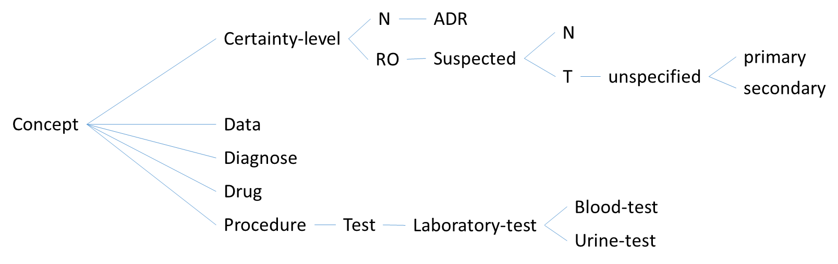

In the case 1, Diagnose has the instances TIA, DU, osteoporosis, stroke, bleeding-ulcer, post-menopausal, DM, hyperthyroidism, malabsorption, and multiple-myeloma. Drug has the subclass PPI with instances Nexium and Omeprazole, and direct instances of Drug aspirin, dipyridamole, and clopidogrel. Five instances of Blood-test are defined: CBC, comprehensive-metabolic-panel, serum-25-hydroxyvitamin, PTH, and serum-protein-electrophoresis; and four for the Urine-test: 24h-urine-calcium, 24h-urine-sodium, 24h-urine-creatinine, and urine-protein-eletrophoresis.

### Processing (1 page):

* If applicable, explain how relevant interactions were (automatically) identified (features A1-A7)

**A1 Drug from a CPG has an effect on a comorbid condition**: The Bleeding-ulcer CIG determines that when the patient is taking aspirin, she is at risk of bleeding ulcer (by means of the SA structure –simplified here- (aspirin T)-(bleeding-ulcer RO)). If the risk is confirmed by means of a bleeding-ulcer-test, aspirin is marked as to cause an ADR, and a PPI drug is introduced by means of the SA structure (aspirine T)(bleeding-ulcer T)-(aspirine ADR)(PPI T).

**A2 Two or more drugs from different CPGs interact**: To be described with later clinical cases.

**A3 Clinical goals from different CPGs conflict**: To be described with later clinical cases.

**A4 Conflicting actions from different CPGs**: In case 1, when PPI is introduced to reduce the effects of confirmed bleeding-ulcer, and the patient is diagnosed of (primary) osteoporosis and, consequently, PPI disapproved, the system detects this conflict. The reaction is that PPI is declared to have an ADR, and consequently the bleeding-ulcer with aspirin condition is disregarded and an alternative to PPI+aspirin solution is searched.

**A5 Duplicate or redundant advice from different CPGs**: To be described with later clinical cases.

**A6 Temporal relationship between different CPGs**: To be described with later clinical cases.

**A7 Multiple interactions from different CPGs interacting at the same time**: Our osteoporosis CIG registers the negative impact of PPI on patients with confirmed osteoporosis. Our bleeding-ulcer CIG also registers the need of PPI to deal with confirmed bleeding ulcer. If the target patient is diagnosed of both osteoporosis and bleeding ulcer, the osteoporosis CIG detects this situation and marks an ADR of PPI. Automatically, the system reacts searching for an alternative to PPI in order to attend the bleeding-ulcer problem, which is now disregarded, after the elimination of PPI.

* Explain how relevant interactions were (automatically) mitigated (features B1-B8 [A8-A14+Other mitigation strategies])

**B1 Adding a drug to mitigate an adverse effect**: In case 1, adding PPI to aspirin in order to mitigate bleeding-ulcer is directly introduced in the form of the explicit SA structure, simplified here: (aspirin T)(bleeding-ulcer T)-(aspirin ADR)(PPI T).

**B2 Adjust drug dosage**: To be described with later clinical cases.

**B3 Monitor the effects of a drug**: Our interpretation of case 1 did not included this situation. However, if periodic monitoring of bleeding ulcer were required, we could define bleeding-ulcer confirmations with a validity period (e.g. 1 month), so that after one month the confirmed true condition bleeding-ulcer would expire, and a new test will be suggested by the system. This behaviour could be conditioned, for example, to the fact that the patient is taking aspirin.

**B4 Replacing a drug with a safer / non-inetracting drug / more effective drug for comorbidity**: In our stroke CIG, we indicate three alternative treatments aspirin alone, aspirin combined with dipyridamole, and clopidogrel. The first time that stroke is detected, aspirin alone is recommended. Then, the bleeding-ulcer CIG make us suspect of bleeding-ulcer for patients taking aspirin. If the ordered test, confirms bleeding-ulcer, aspirin treatment is cancelled, which causes the stroke problem to be disregarded. As a consequence, the system tries to solve the problem with an alternative treatment. In our case, the second treatment with aspirin combined with dipyridamole is discarded because it contains aspirin, and this drug is marked as causing an ADR in the patient. As a result, the third treatment with clopidogrel is suggested.

**B5 Discard unsafe/interacting drug**: In case 1, this is the case of aspirin explained before, which is unsafe when the patient has duodenal-bleeding-ulcer confirmed. Treatments including aspirin are since-then discarded.

**B6 Delay a task to avoid a temporal overlap**: To be described with later clinical cases.

**B7 Add a task to ensure a temporal overlap**: To be described with later clinical cases.

**B8 Other mitigation strategies**: To be considered in later clinical cases.

* If applicable, explain how other relevant features were realized (features C1-C4[A15-A18] )

**C1 Patient preferences and/or patient burden**: The stroke CIG incorporates three alternative treatments. When the patient is initially detected a risk of stroke because of past TIA, all three treatments are possible. Our system implements a function for selecting among alternative treatments, this function can be changed and defined in function of the treatment costs and risks, otherwise, the default selection criterion is in the order of introduction. The current implementation of case 1 uses this default criterion, so the first try is to go for aspirin, then for aspirin plus dipyridamole, and finally for clopidogrel.

**C3 Explanation of the mitigation strategy(ies)**: Explanations are optional and bounded to the SA structures that implement the CIGs. In the case 1, some of the possible explanations displayed are “Aspirin is recommended to deal with the risk of stroke (Class 1, Evidence Level B)”, “Risk of osteoporosis detected due to post-menopausal condition”, “DM suggests secondary osteoporosis”, etc.

Note that the current explanations are made for the purpose of this study, but they should be reviewed before a professional use of the system.

**C4 Alternative mitigation strategies for a single interaction**: To be described with later clinical cases.

* Explain which parts of the processing are generic and which need to be hardwired for the case[1]

Processing is not hard-wired. Knowledge is generic and based on both, the CPGs and the pharmacological guidelines (e.g., MEDIMECUM).

### Output (1 page):

* Show and explain how the result of the processing is represented

For this case study, we used a textual representation of the results. The system is based on the information available in the clinical record of the patient. The processing loop, applies sequentially all the SA units of knowledge that are applicable to the current condition of the patient (i.e., her clinical record). For each SA unit applied, an explanation is provided, and the clinical record modified accordingly. For testing purposes in this study, the record of the patient is also displayed after each unit of SA knowledge is applied. Following we provide an excerpt of the output generated during the reasoning process on the case 1:

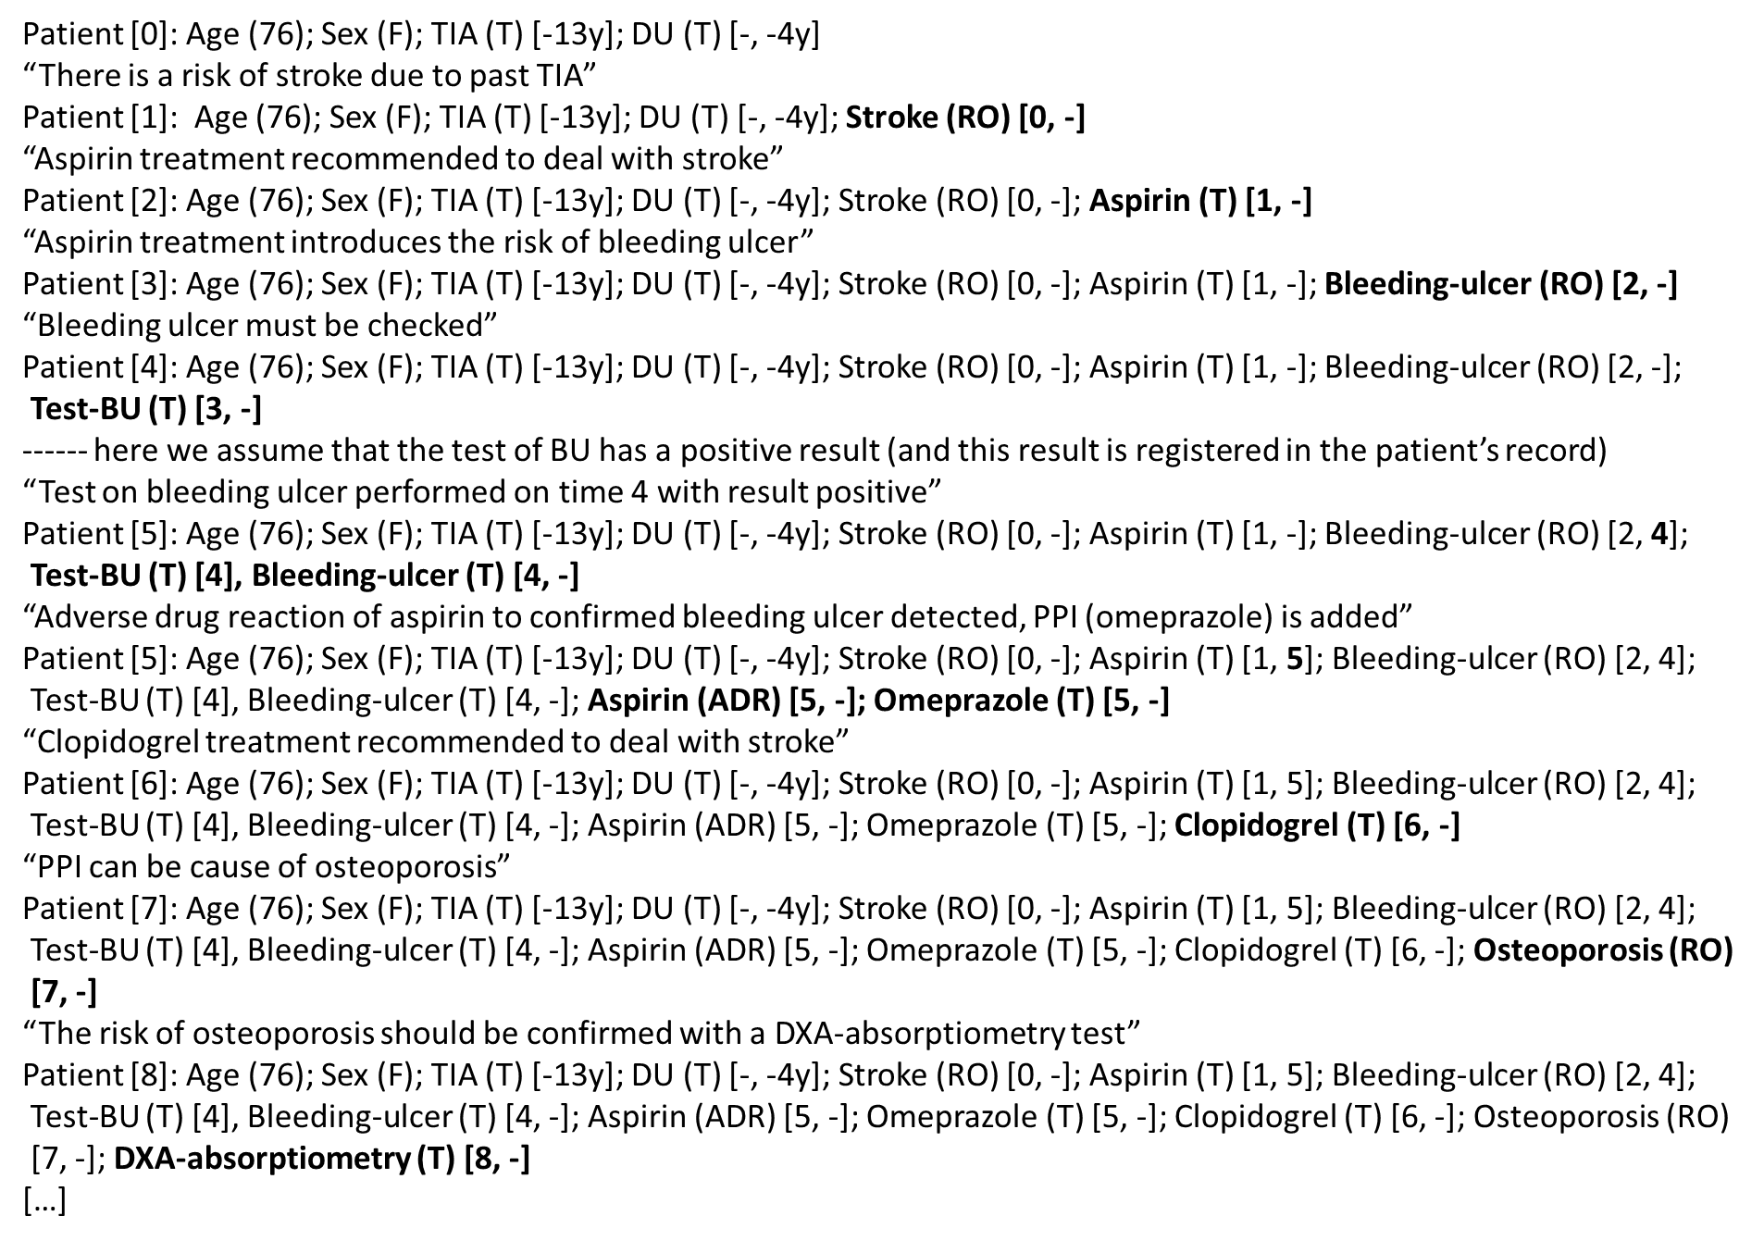

Note that all the lines Patient [X] display the contents of the patient’s record, at step X. This information is followed by an explanation of the knowledge applied, which modifies the patient’s record.

* Show and explain what user interactions were involved in the use case

The only interactions in case 1 were related to the results of the prescribed tests. Every time a test is asked, this demand is stored in the patient’s record together with the time restriction on the correct time to perform that test. Once this time arrives, the user is asked to provide the result of the test. This result is annotated in the patient’s record and, from then, it can be used by other knowledge to make new suggestions. All these suggestions (e.g., a drug prescription) could also be asked to the user for confirmation, but this execution mode was not the one used in this study. Contrarily, all the clinical actions suggested by the system were automatically accepted with no need for a user validation. The purpose was to simplify the test of the system in case 1.

* Explain any additional considerations.

Not applicable in case 1

### CASE 2

### Input (1 page):

* Show the encoded CIGs required to solve the case in your approach formalism
* Show the encoded patient data
* If applicable, show how adverse interactions (features A1-A7) were encoded a-priori
* If applicable, show/reference the encoding of additional domain knowledge

### Processing (1 page):

* If applicable, explain how relevant interactions were (automatically) identified (features A1-A7)
* Explain how relevant interactions were (automatically) mitigated (features B1-B8 [A8-A14+Other mitigation strategies])
* If applicable, explain how other relevant features were realized (features C1-C4[A15-A18] )
* Explain which parts of the processing are generic and which need to be hardwired for the case[2]

### Output (1 page):

* Show and explain how the result of the processing is represented
* Show and explain what user interactions were involved in the use case
* Explain any additional considerations.

### CASE 3

### Input (1 page):

* Show the encoded CIGs required to solve the case in your approach formalism
* Show the encoded patient data
* If applicable, show how adverse interactions (features A1-A7) were encoded a-priori
* If applicable, show/reference the encoding of additional domain knowledge

### Processing (1 page):

* If applicable, explain how relevant interactions were (automatically) identified (features A1-A7)
* Explain how relevant interactions were (automatically) mitigated (features B1-B8 [A8-A14+Other mitigation strategies])
* If applicable, explain how other relevant features were realized (features C1-C4[A15-A18] )
* Explain which parts of the processing are generic and which need to be hardwired for the case[3]

### Output (1 page):

* Show and explain how the result of the processing is represented
* Show and explain what user interactions were involved in the use case
* Explain any additional considerations.

### CASE 4

### Input (1 page):

* Show the encoded CIGs required to solve the case in your approach formalism
* Show the encoded patient data
* If applicable, show how adverse interactions (features A1-A7) were encoded a-priori
* If applicable, show/reference the encoding of additional domain knowledge

### Processing (1 page):

* If applicable, explain how relevant interactions were (automatically) identified (features A1-A7)
* Explain how relevant interactions were (automatically) mitigated (features B1-B8 [A8-A14+Other mitigation strategies])
* If applicable, explain how other relevant features were realized (features C1-C4[A15-A18] )
* Explain which parts of the processing are generic and which need to be hardwired for the case[4]

### Output (1 page):

* Show and explain how the result of the processing is represented
* Show and explain what user interactions were involved in the use case
* Explain any additional considerations.

1. There are two aspects: (**1**) processing algorithm: in a generic approach, only models change across case studies, while a hardwired approach requires tweaking the algorithm for each case study; (**2**) domain knowledge: a mitigation strategy can be generic or hardwired: e.g., deriving which drug should replace another drug can come from a knowledge base or be hard-wired for each case study (e.g., based on guidelines). There can be degrees of generality as well, of course.
2. There are two aspects: (**1**) processing algorithm: in a generic approach, only models change across case studies, while a hardwired approach requires tweaking the algorithm for each case study; (**2**) domain knowledge: a mitigation strategy can be generic or hardwired: e.g., deriving which drug should replace another drug can come from a knowledge base or be hard-wired for each case study (e.g., based on guidelines). There can be degrees of generality as well, of course.
3. There are two aspects: (**1**) processing algorithm: in a generic approach, only models change across case studies, while a hardwired approach requires tweaking the algorithm for each case study; (**2**) domain knowledge: a mitigation strategy can be generic or hardwired: e.g., deriving which drug should replace another drug can come from a knowledge base or be hard-wired for each case study (e.g., based on guidelines). There can be degrees of generality as well, of course.
4. There are two aspects: (**1**) processing algorithm: in a generic approach, only models change across case studies, while a hardwired approach requires tweaking the algorithm for each case study; (**2**) domain knowledge: a mitigation strategy can be generic or hardwired: e.g., deriving which drug should replace another drug can come from a knowledge base or be hard-wired for each case study (e.g., based on guidelines). There can be degrees of generality as well, of course.